

WILLETTON SENIOR HIGH SCHOOL

**YEAR 12 PHYSICS 2021**

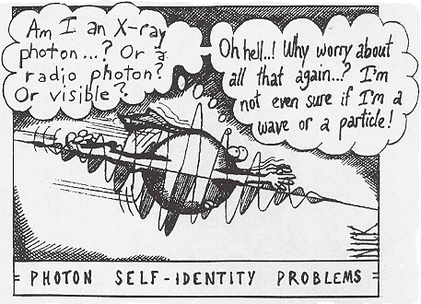

**TASK 8**

**TEST 4: Power Generation, Wave Particle Duality & Quantum Theory**

**NAME: __________________________**

**TEACHER: _______________________**

**MARKS**

**/55**

**Instructions:**

1. Answer **all** the questions in the spaces provided.
2. Where appropriate, for numerical answers express your answers correct to

3 significant figures. Estimates should be given to 2 significant figures.

1. Not all question carry equal number of marks. The marks available for each question are shown.

4. Show working out steps neatly, logically and clearly to score full marks.

5. You may only use a scientific calculator.

6. **Write with a blue or black ink pen.** You may use a lead pencil to draw

diagrams.

Question 1. (4 marks)

Light is said to exhibit dual properties.

(a) What is meant by the dual nature of light? (2 marks)

_________________________________________________________________________

_________________________________________________________________________

_________________________________________________________________________

(b) Give one example of each of the properties of light that support its dual nature. (2 marks)

Example 1: ______________________________________________________________

________________________________________________________________________

Example 2: _______________________________________________________________

________________________________________________________________________

Question 2. (4 marks)

Both the Sun and an electric light globe emit a continuous spectrum of visible light. However, there are dark lines in the Sun’s spectrum (called Fraunhofer Lines) which are not seen in the spectrum of the light globe. Explain how these line occur.

_________________________________________________________________________

_________________________________________________________________________

_________________________________________________________________________

_________________________________________________________________________

_________________________________________________________________________

_________________________________________________________________________

Question 3. (9 marks)

The primary coil of a 9.00 kW step-up transformer is drawing power from a generator. The primary coil draws a peak current of 25.0 A. The secondary coil of the transformer has 555 turns of wire and produces a peak voltage 5.40 kV. Assume the transformer is ideal.

1. Determine the ratio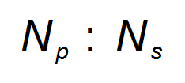in its simplest form. (3 marks)

1. Determine the number of turns of wire in the primary coil. (1 mark)

1. Determine the RMS current on the secondary side of the transformer. (3 marks)

1. State and explain one (1) possible source of power loss within non-ideal transformers.

(2 marks)

________________________________________________________________

________________________________________________________________

________________________________________________________________

_______________________________________________________________

Question 4. (4 marks)

Below is a typical black-body curve at a certain temperature.

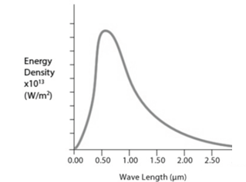

(a) What are the characteristics of an ideal black body? (2 marks)

______________________________________________________________________

______________________________________________________________________

______________________________________________________________________

______________________________________________________________________

(b) If the temperature of the black-body is halved, sketch on the above graph the shape of the new curve. (2 marks)

Question 5. (4 marks)

An AC generator produces a peak voltage of 3.18 kV. The coil is circular with a diameter 26.0 cm and sits in a magnetic field of 9.00 × 10-2 T.

The graph below shows the variation of voltage generated with time.

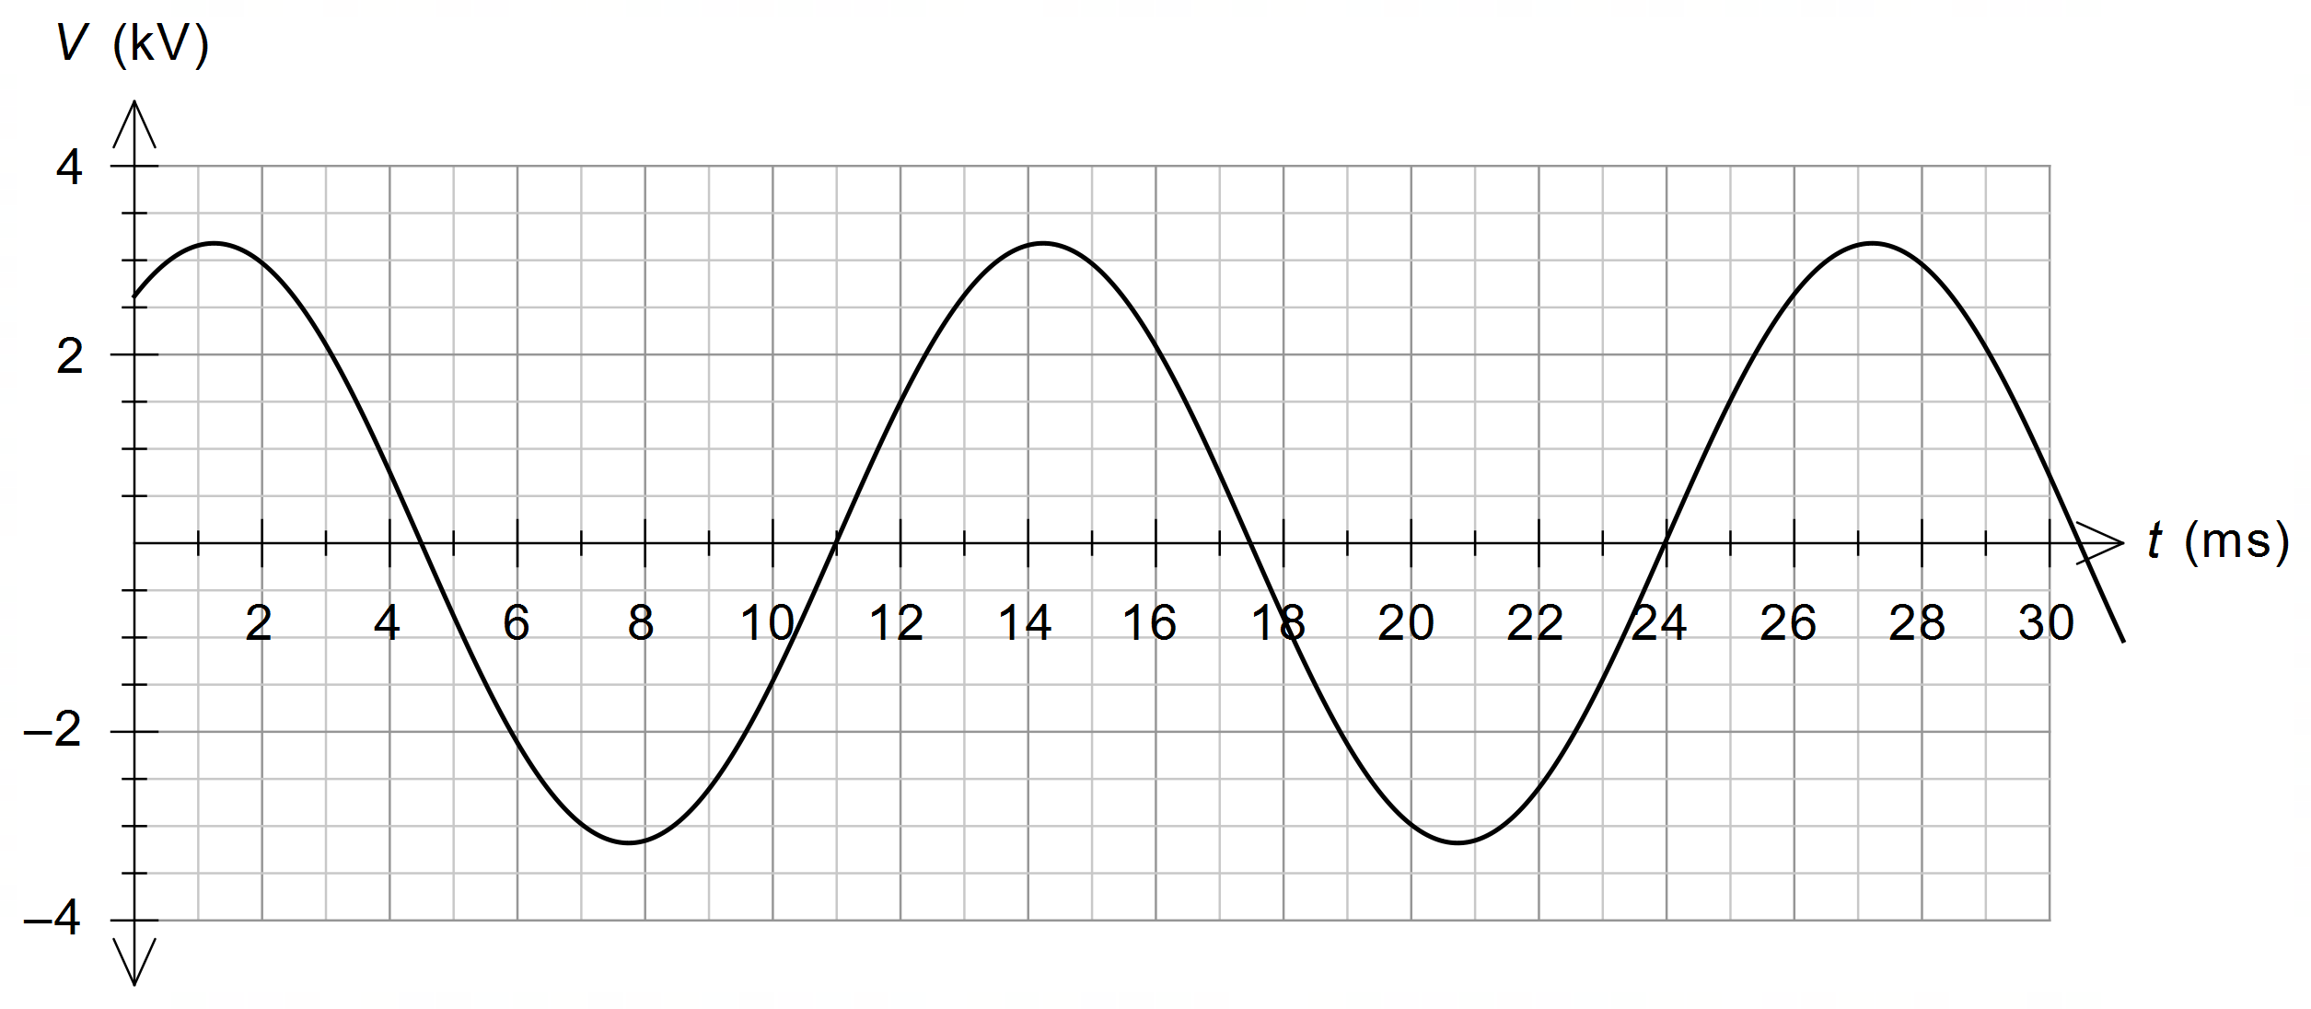

Use this information to **estimate** the number of turns of wire in the generator coil.

Give your answer to an appropriate number of significant figures.

Question 6. (4 marks)

A non-ideal intermediate transformer accepts electrical energy from a long-distance transmission line at a rate of 270 MW and has an output voltage of 13.0 kV. After the intermediate transformer, electrical energy is delivered to a local transformer at a rate of 231 MW and 11.5 kV along a 2.50 km long line, having a resistance rating of 0.0750 Ω km–1. Determine the percentage efficiency of the intermediate transformer. Show working.

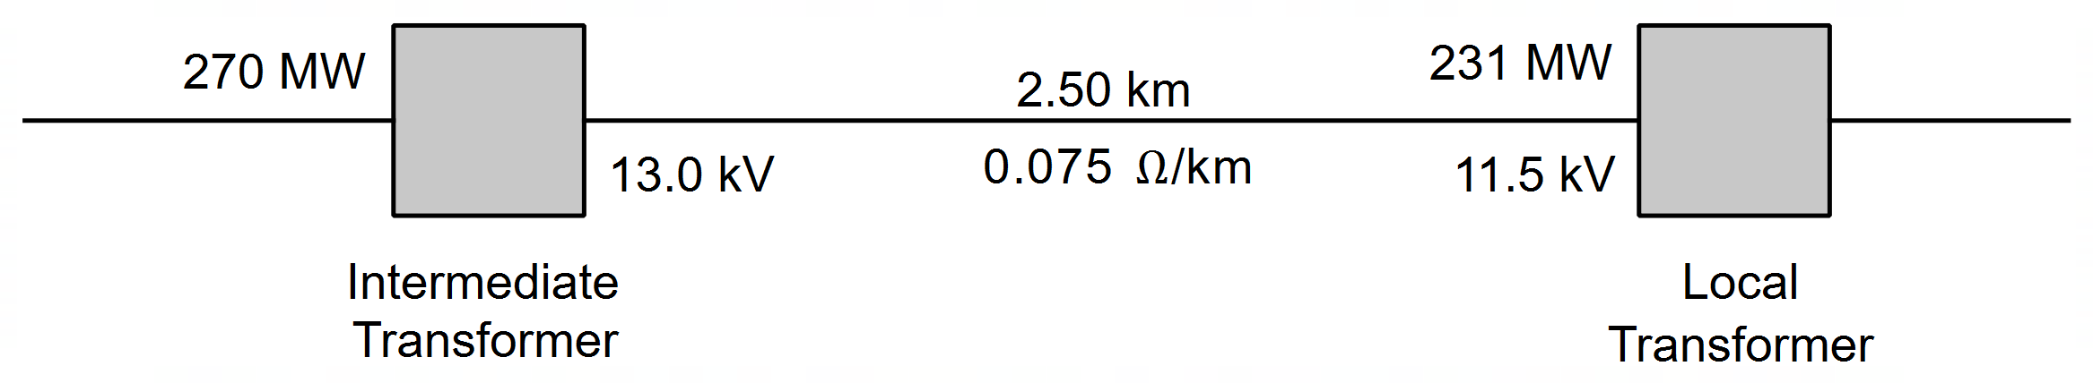

Question 7. (6 marks)

1. Derive the expression

𝝀 = $\frac{h}{√2mqV}$

for a particle of mass m and charge q, which is being accelerated through a potential difference V. (4 marks)

1. If you double the kinetic energy of a particle, how does the de Broglie wavelength change? Show your working. (2 marks)

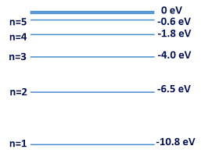Question 8. (9 marks)

The figure at right illustrates some of the valence electron energy levels in a gaseous atom of a particular element. The energies of the levels are given in electron volts (eV).

(a) The valence electron of the atom is in the lowest energy level shown. What is the ionisation energy of the atom in joules? (2 marks)

(b) State two physical processes by which an electron in the ground state can move to a higher energy level. (2 marks)

______________________________________________________________________

______________________________________________________________________

A cold gaseous sample of the element is bombarded by electrons of energy 9.50 eV and observed to emit electromagnetic radiation.

(c) Show on the diagram above the energy level transitions that cause this emission of electromagnetic radiation. (2 marks)

(d) Calculate the longest wavelength of the emitted electromagnetic radiation.

(3 marks)

Question 9. (5 marks)

Physics students studying interference set up a double slit experiment using a 615 nm laser as shown below.

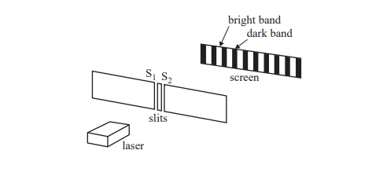

The power output of the laser is 5.03 x 10-3 Js-1.

(a) Calculate the number of photons leaving the laser each second. (3 marks)

A section of the interference pattern observed by the students is shown below. There is a bright band at point C, the centre of the pattern.



(b) Explain why point C is a bright band and not a dark band. (2 marks)

_________________________________________________________________________

_________________________________________________________________________

_________________________________________________________________________

_________________________________________________________________________

10. (6 marks)

The diagram below shows a smoke alarm unit that contains a light-emitting diode (LED) and a photocell. When smoke particles enter the unit they reflect some of the monochromatic light from the LED onto the photocell. This causes the metal in the photocell to release electrons, causing an alarm to sound. The metal used in the photocell has a work function of 1.55 eV.

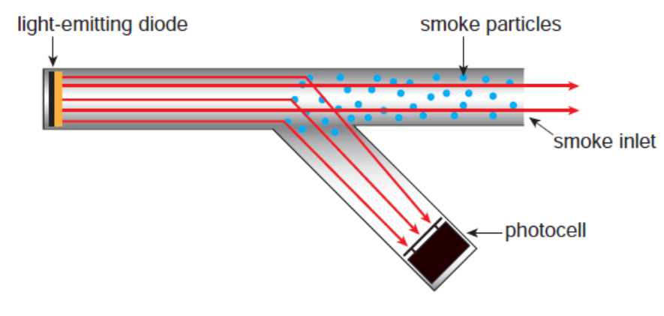

(a) Calculate the threshold frequency for the metal used in the photocell. (3 marks)

(b) The number of smoke particles in the smoke alarm unit increases. Use the concept of photons to explain the effect of the increased number of smoke particles on the **number** and **energy** of the electrons released in the photocell. (3 marks)

_________________________________________________________________________

_________________________________________________________________________

_________________________________________________________________________

_________________________________________________________________________

_________________________________________________________________________

END OF TEST